Lab Exercise 6:
1. Write a C program to implement a stack using an array with the following operations:
1. push() 2. pop() 3. peek() 4. display()
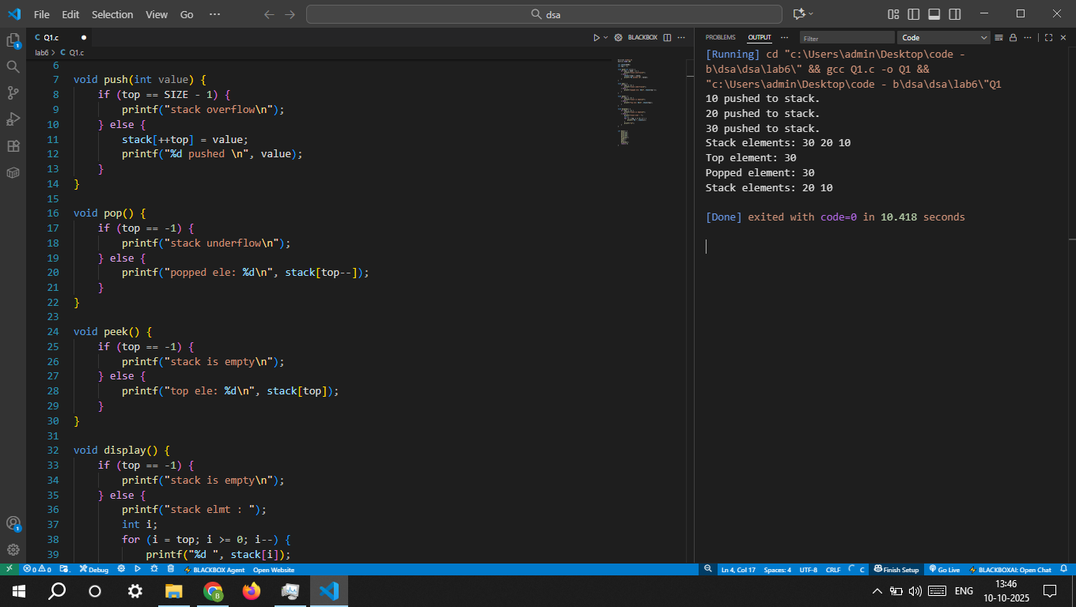

2. Repeat the above with menu driven approach. 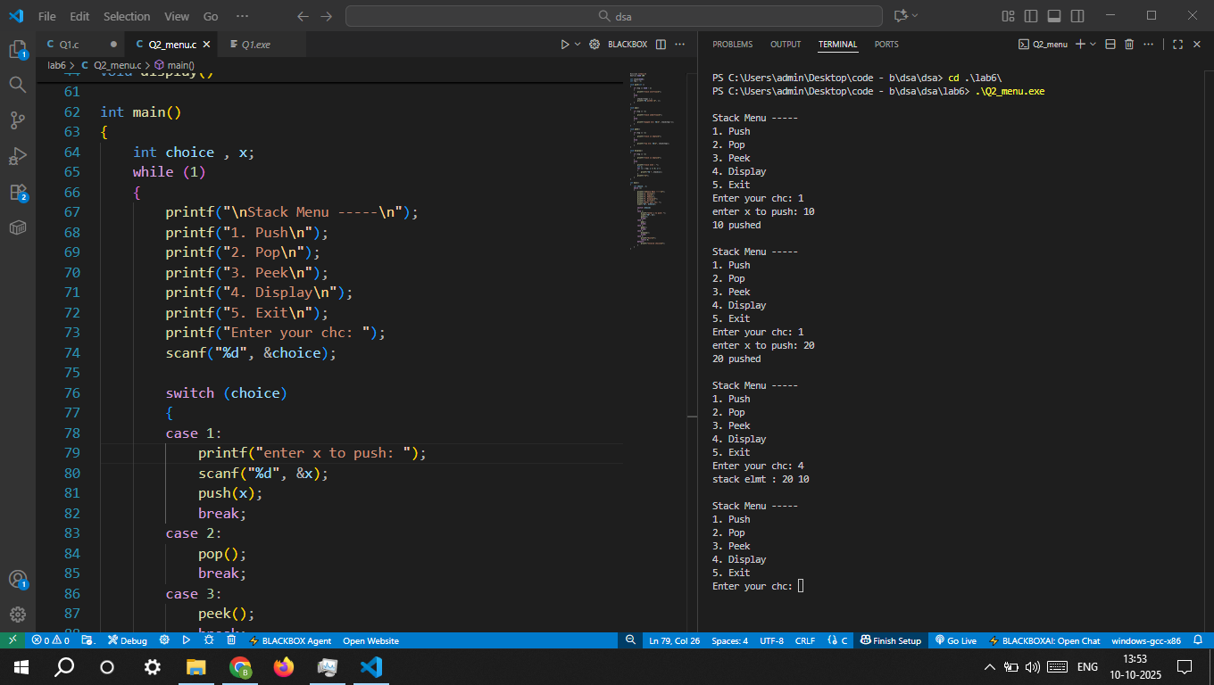

3. Reimplement Q-1 in C++ using a class-based approach. 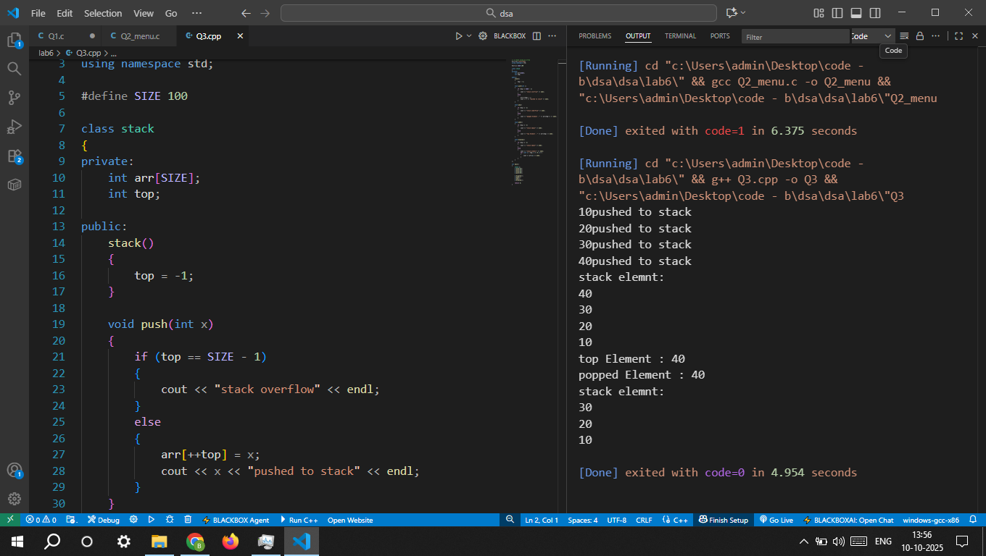

4. Implement a stack using a singly linked list with push, pop, and display in C.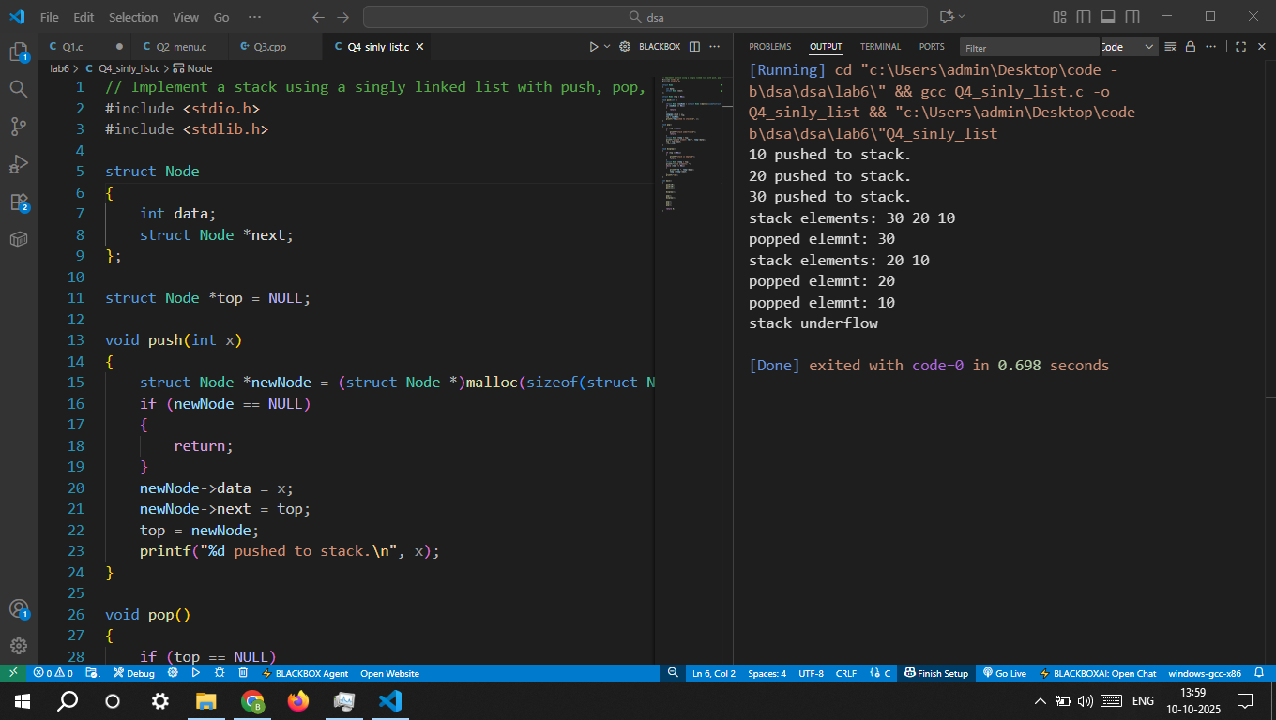
5. Repeat the above with menu driven approach. 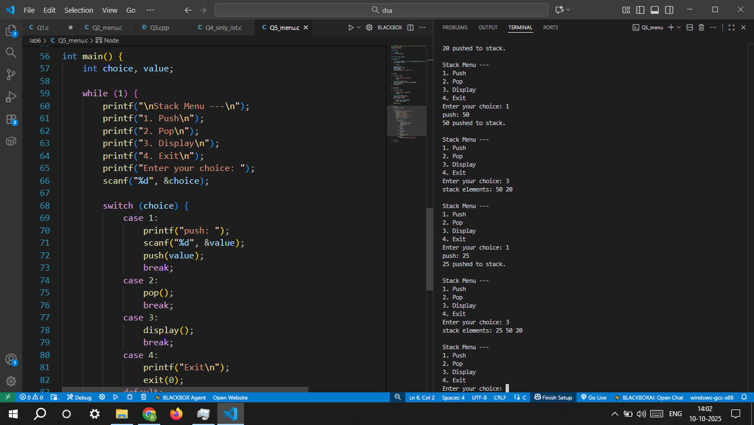

6. Implement stack operations using Linked List in C++ with classes and objects.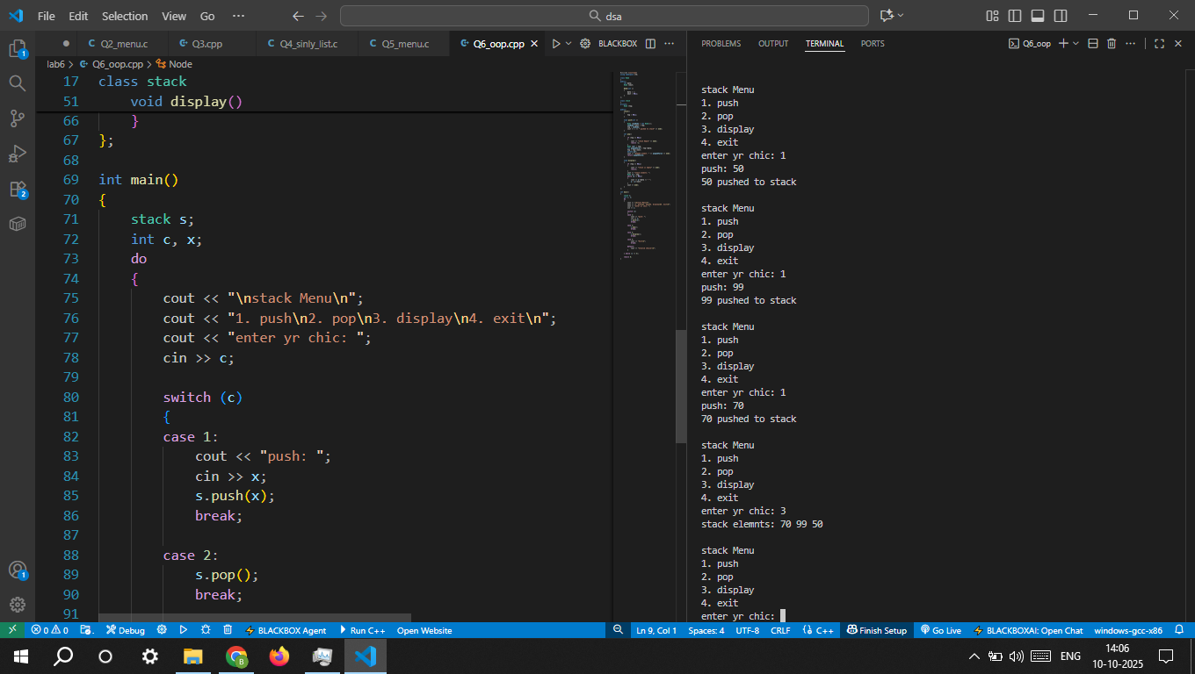

7. Write a program to demonstrate the use of the stack container in C++ STL by performing:
o Push elements
o Pop elements
o Access top() element
o Display size and empty status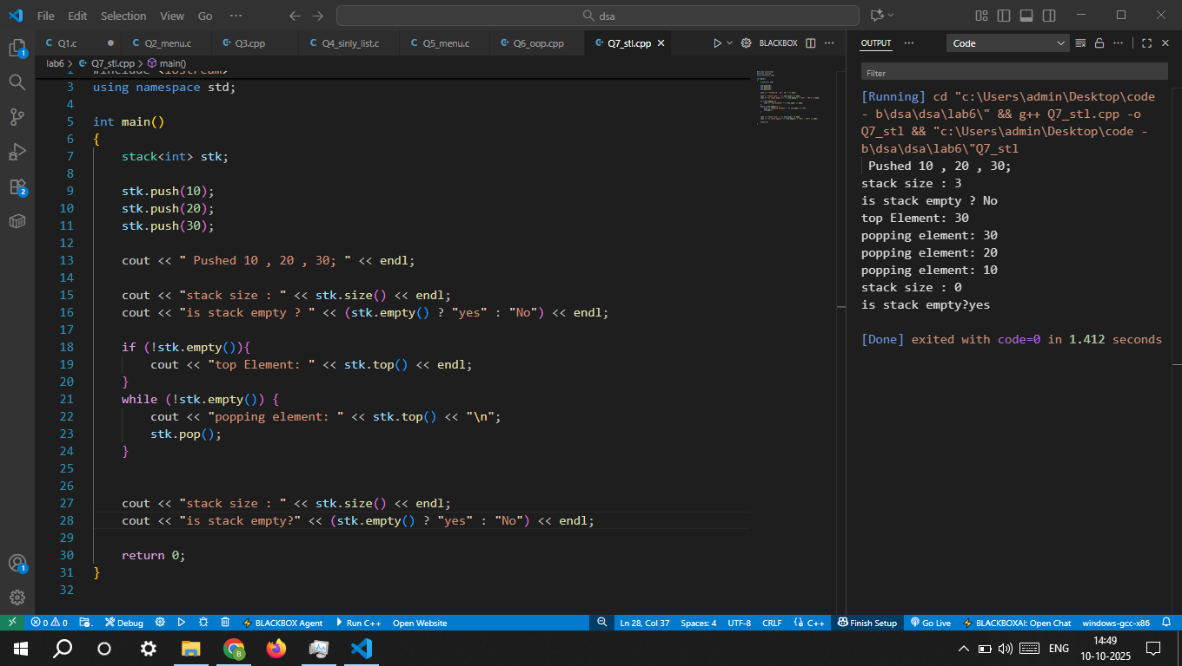

8. Write a program in C to implement two stacks in one array such that:
o Stack 1 grows from left to right.
o Stack 2 grows from right to left.
o The program should support push1(), push2(), pop1(), pop2() and check for overflow/underflow conditions.
Hint:
• Use a single array arr[MAX].
• Maintain two top variables: int top1 = -1; int top2 = MAX;
• Stack1 elements go into arr[++top1].
• Stack2 elements go into arr[--top2].
• Overflow occurs if top1 + 1 == top2.

9. Repeat the above in C++ using a class-based implementation. 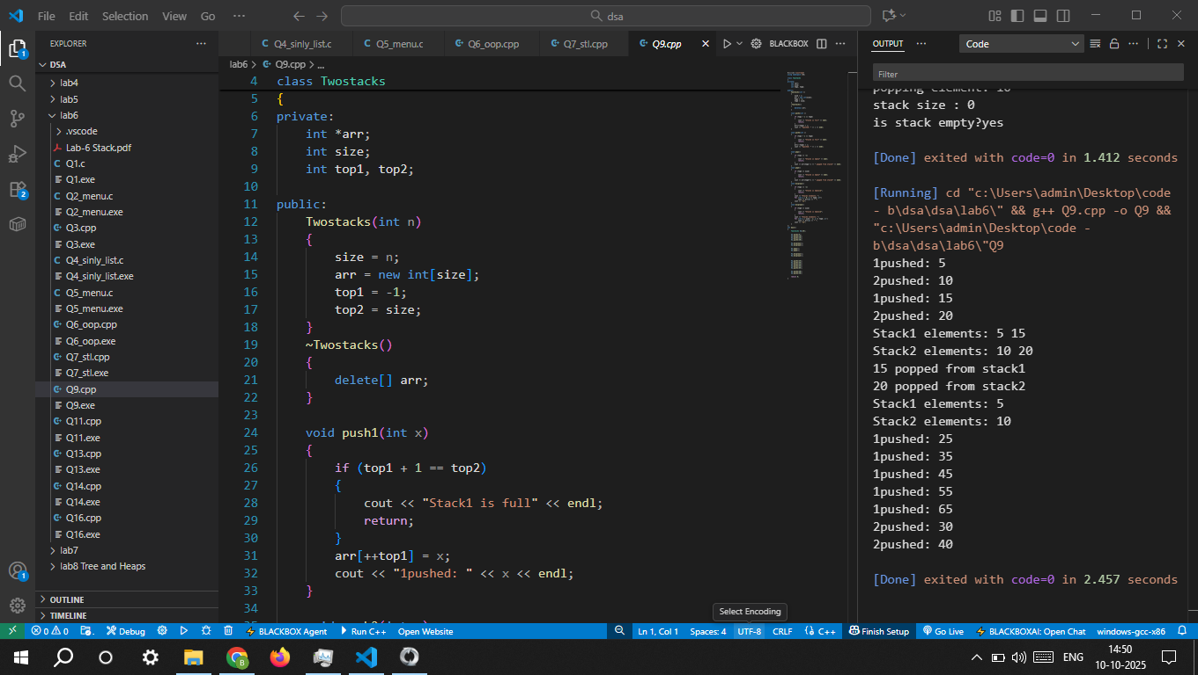

10. Write a program to reverse a string using a stack implemented with arrays.
11. Write a program to reverse a string in C++ using the stack STL.
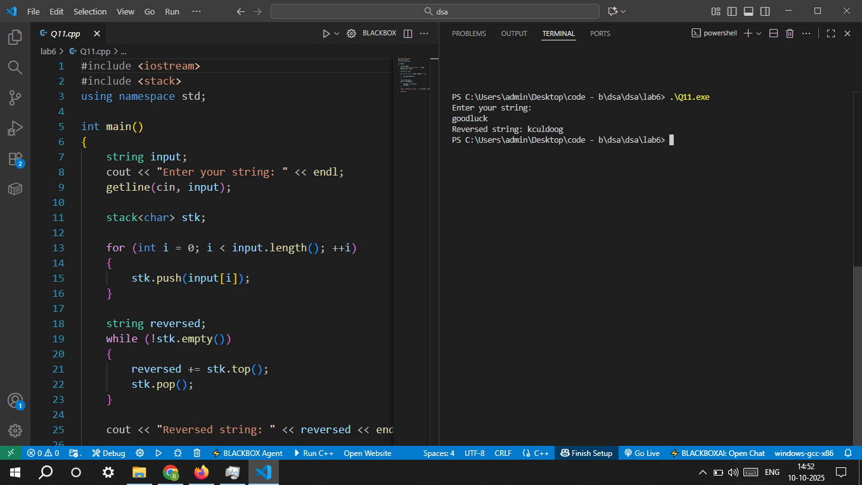
12. Write a program to reverse an integer array using a stack (implemented with array).
13. Write a program n C to check whether a given expression has balanced parentheses using a stack (array/linked list). 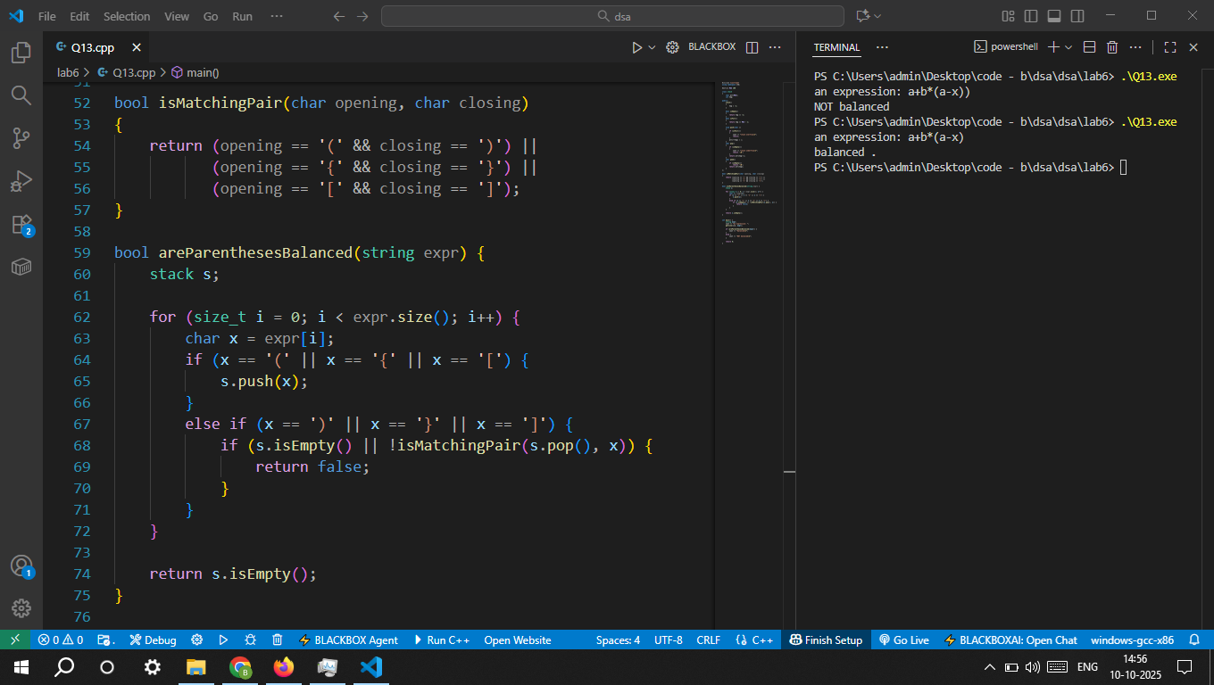
14. Repeat the above using STL stack. 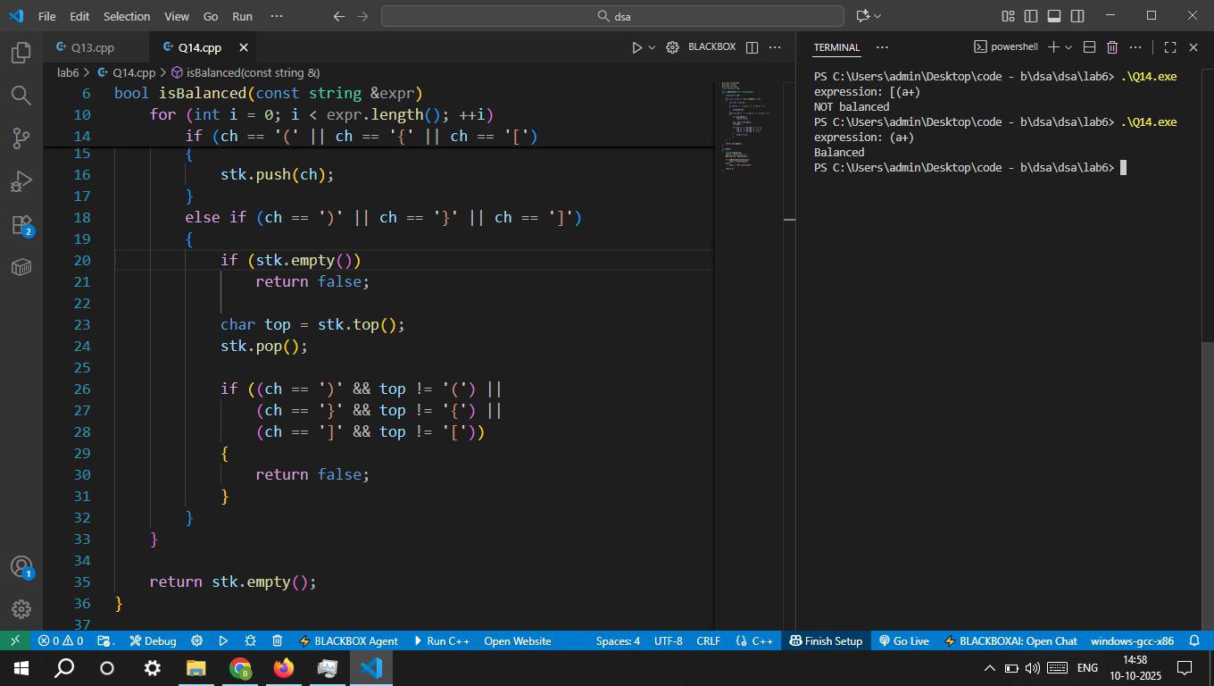
15. Write a program in C to convert an infix expression to a postfix expression using a stack.
16. Repeat the above in C++ using STL stack.